
366Pi Technologies Official Website (in.linkedin.com)
1 key takeaways of 366 pi
- FloCard: FloCard has emerged from evolution and numerous attempts and failures. Unlike all other products that have history behind their development, FloCard has its origin story. The successive outbreaks of the COVID-19 pandemic have taught us many lessons about contactless nature, digital, oxygen, and an environmentally friendly surrounding. FloCard was an idea developed much before the onset of the pandemic way back in October 2018. Nevertheless, its significance was discovered during the period of the pandemic. FloCard was conceived as a product somewhere within the pandemic period. It symbolises a commitment to growth without affecting the environment.
It is a one-time initiative for the purpose of helping individuals, businesses, governments, and organizations to meet their sustainable development goals (SDG 2030). FloCard can be considered to be a #BetterPlanetTogether campaign for an impactful effect on planet earth.

- Indian Agriculture Dashboard: Indian Agriculture Dashboards refer to software applications or websites where agriculture information is displayed to users in an easy-to-understand manner. It enables individuals and organizations working in the field of agriculture to monitor information regarding agriculture output, climate conditions, and market status.
- Provides latest information on agriculture.
- Tracks agricultural activities.
- Aids in better decision making by the users.
- Provides information regarding weather, markets, and productivity.
- Promotes technological-based agricultural practices.

- AI in Automobiles:AI in Automobiles involves the application of Artificial Intelligence in the automobiles industry to enhance the functionality of automobiles. AI allows automobiles to make informed choices by taking into account data and various technologies. AI in automobiles plays an essential role in innovations in the automotive technology industry.
- Utilizes AI technology in the improvement of automobile systems.
- Promotes automation and smart automobiles operation.
- Allows for data analysis and intelligent decision making.
- Increases safety, effectiveness, and overall experience.
- Promotes innovation within the automotive technology industry.

2. Create FloCard:
- Sign up and generate your digital FloCard.
- Add relevant personal and professional details.
- Exchange cards with at least 3 team members
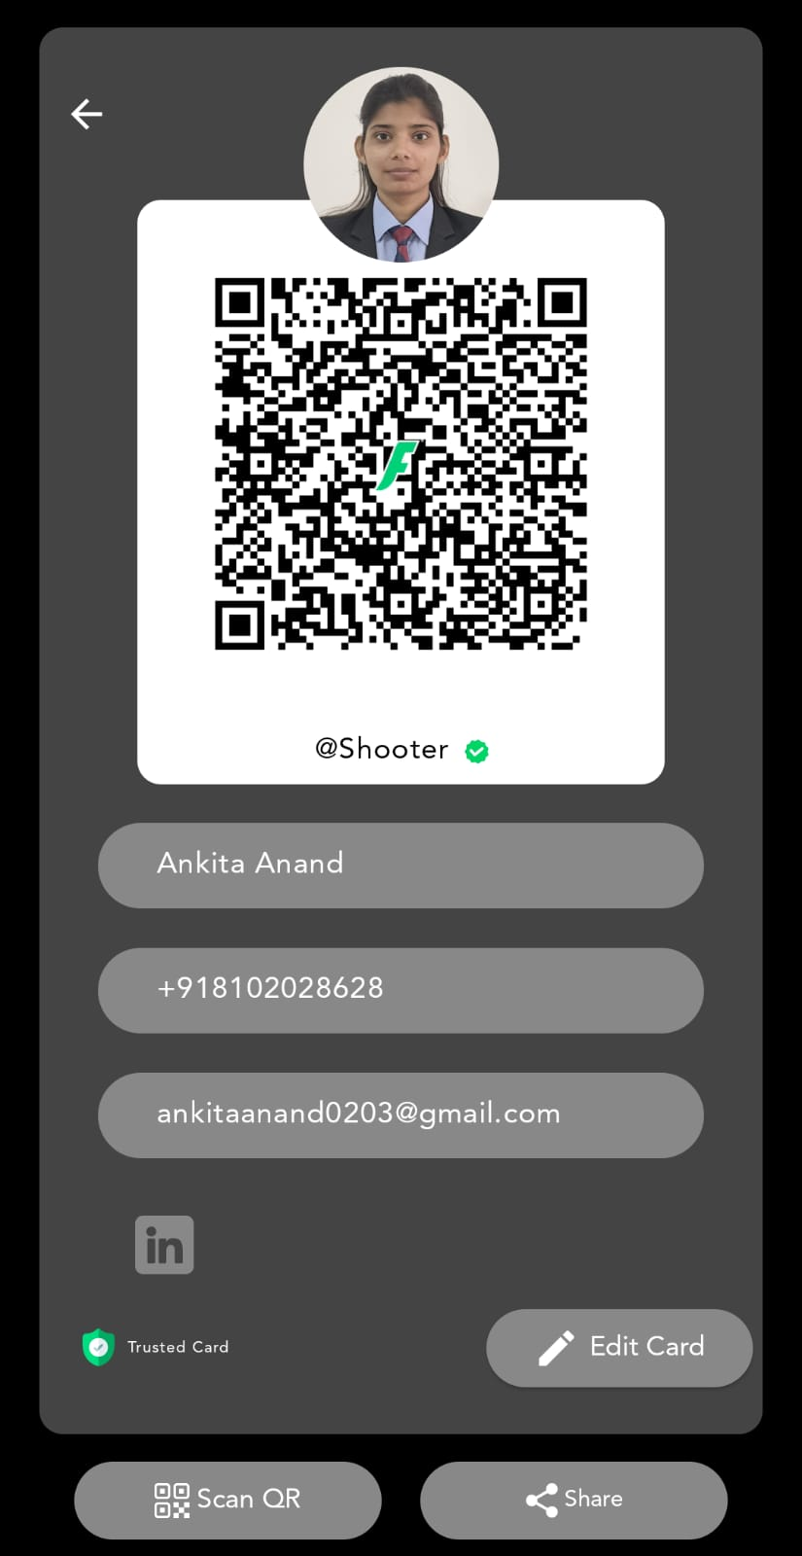
- Sign up and generated digital FloCard.
- Added relevant personal and professional details.
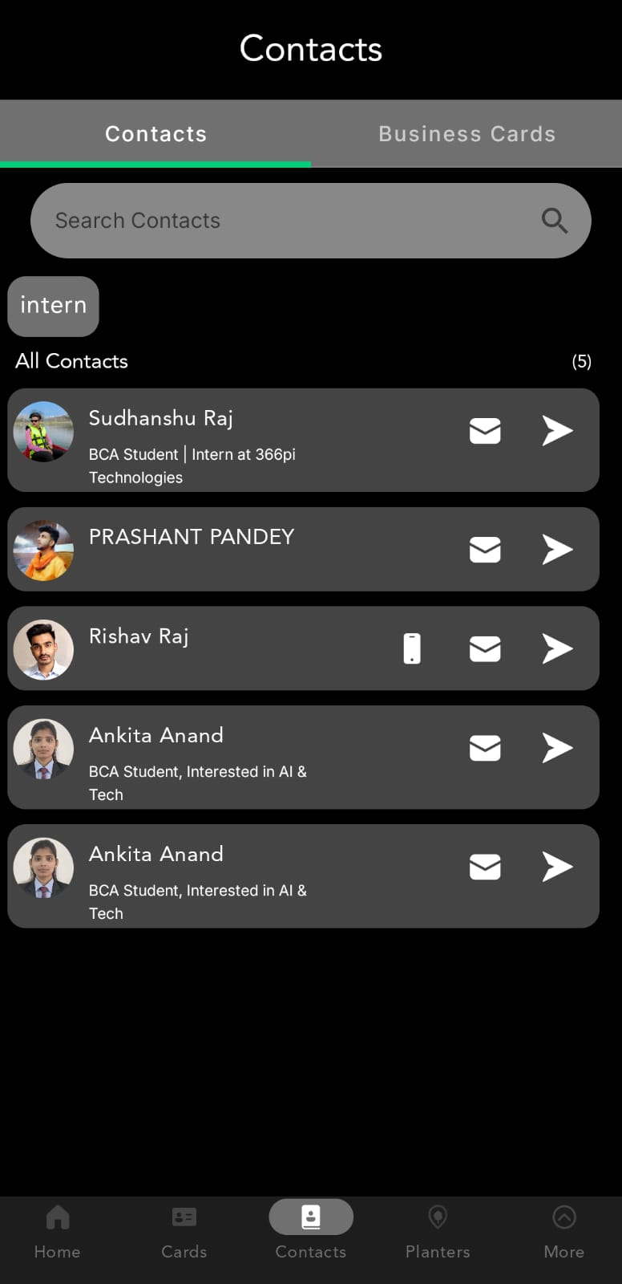
- Exchange cards with at least 3 team members.

3. Understand the FloCard Ecosystem Flow:
- FloCard helps its users develop a digital identity.
- The application offers contactless communications and networking.
- The platform focuses on being environmentally friendly and paperless.
- It also ensures sustainable growth through digital technologies.
Map how the platform flows for:
- Individuals.
- Communities .
- Tree Planters.
Individuals:
- Construct your digital identity with FloCard.
- Exchange personal and contact details electronically.
- Interact and connect without physical meetings.
- Contribute to green communications and transactions.
Communities:
- Develop digital relationships among community members.
- Make sharing of information easier and faster.
- Encourage cooperation within the community.
- Facilitate digital communication for sustainability.
Tree Planters:
- Join and display their tree plantation efforts digitally.
- Demonstrate environmental contributions through FloCard.
- Create awareness regarding green practices.
- Help protect the environment digitally.

Summary:
In today’s journey, I got an insight into 366Pi Technologies and FloCard along with their digital and sustainable solutions. I came to know about the ecosystem flow of FloCard for Individuals, Communities, and Tree Planters.
Also, I made my own digital FloCard, updated my information, and interacted with other teammates using digital cards.
Looking forward to learning more during this internship experience!

